**Solutions:**

**1. What is the emissions per capita of Canada?**

**Ans.** 18 Emissions/Capita

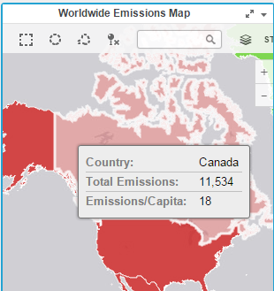

**2. What is the overall trend in worldwide emissions?**

**Ans.** (a) Population increased, (b) Total Emissions increased, (c) Usage of fuel increased.

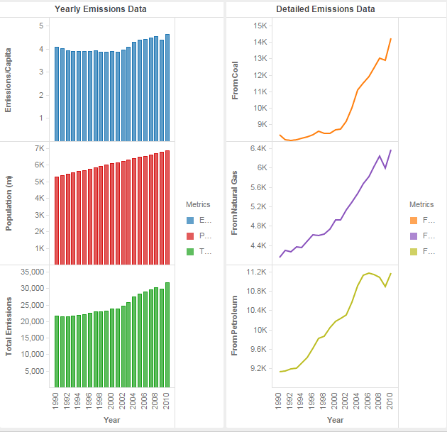

**3. Notice that overall emissions declined in 2009, the only year in the total number of**

**years surveyed that indicates emissions decreases in all three emissions sources. Why**

**is that? What broader socio-political context might explain this single yearly**

**decrease?**

**Ans.** Between year 2008 and 2009, the emissions decreased in all three emissions sources. It may be due to global financial crisis during 2008.

